**VeLa Model Source Plug-In**

The Vela model Source plug-in is accessible from the File menu and allows one to create a ‘continuous’ plot from a VeLa model created with “Polynomial Fit”, “Fourier Model”, or similar tools. It works as an observation source and creates new data series independent of other data series (unlike the “VeLa Model Creator” plug-in).

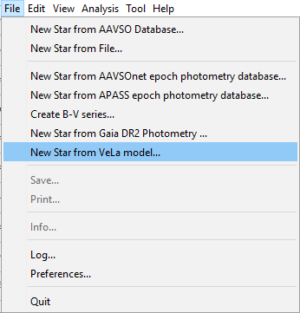

The model function f must be defined in the same manner as for “VeLa Model Creator” (see the ‘VeLa Model Creator Plug-In” documentation for details).

Here is an example of how to create the model data series:

1. Select “New Star from AAVSO Database…”. Enter V405 Dra in the “Star” field and replace Minimum JD with 2459430 and Maximum JD with 2459504. Click OK. This will give you:

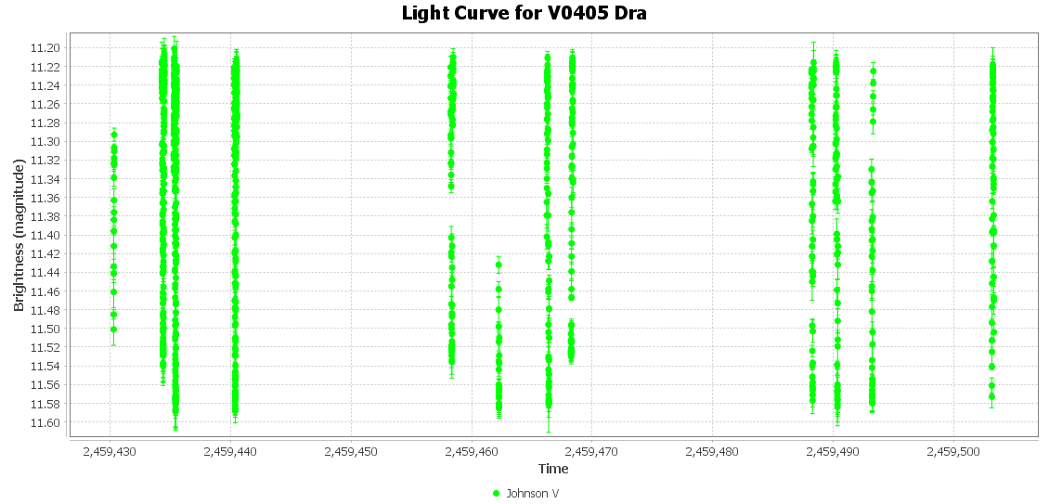

1. Convert time to HJD with Tools->Heliocentric JD converter.
2. Create a Fourier model (Analysis->Fourier Model) for the Johnson V series with a single period of 0.4130506 and 6 harmonics.
3. Now open the model (Analysis->Models…, [Show Model]):

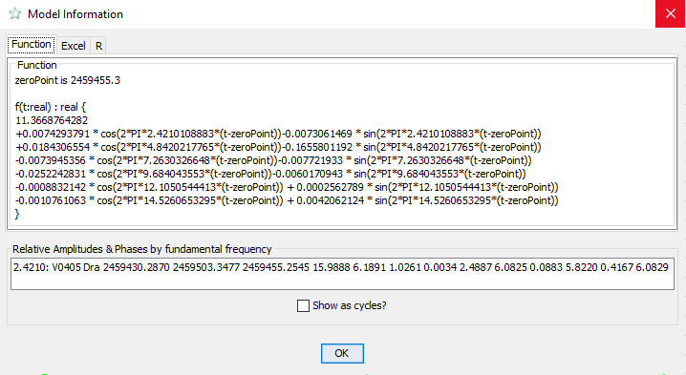

1. Select the function text with the mouse and copy it to the clipboard.
2. From the File menu, select “New Star from VeLa model…”
3. Paste the previously copied text into the big text box, put 2459458 into Minimum JD, 2459468 into Maximum JD, and specify 5001 points to calculate. Left “Add to current?” checked:

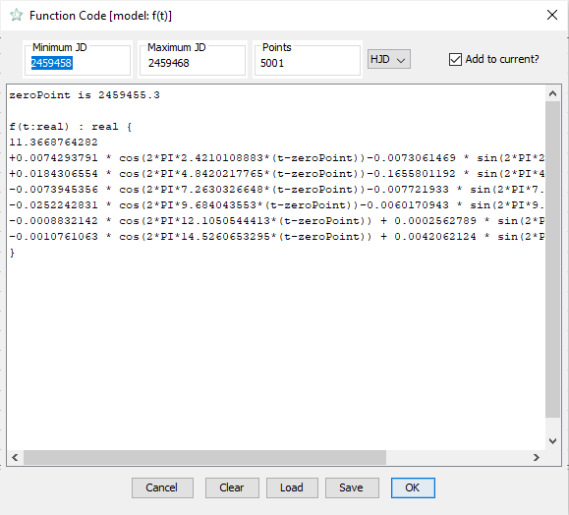

Then press OK.

This will create a new series for you, the “VeLa model”:

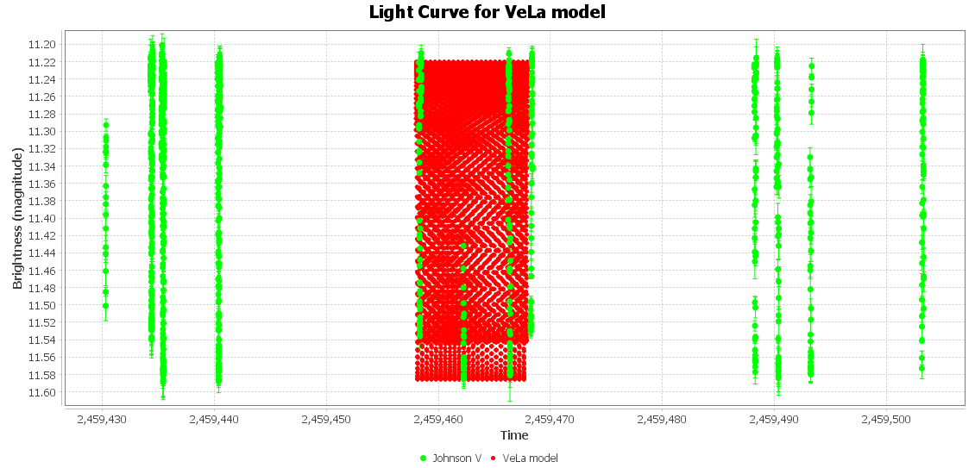

If you zoom in on the plot, you will see a model points calculated with the step (Maximum JD - Minimum JD) / Points = 0.002 days:

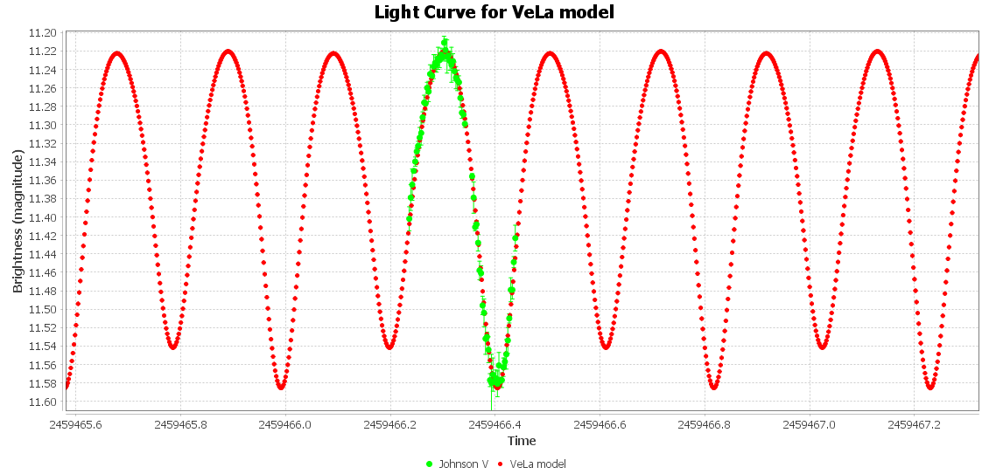

Maksym Pyatnytskyy

Rev A

2022-05-09

**Revision History**

| **Rev** | **Date** | **Description** |
| --- | --- | --- |
| A | 2022-05-09 | Initial Release |